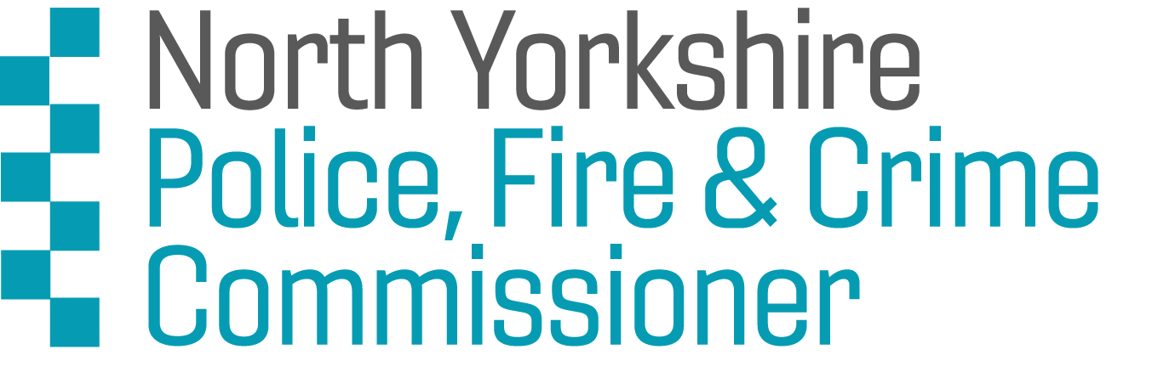

North Yorkshire Youth Commission on Police and Crime 2021 :
Application Form

We are looking for applications from 14-25 year olds from North Yorkshire – including York, Harrogate, Selby, Skipton, Scarborough, Ryedale, Richmondshire and Hambleton.

Section 1: Your details
NAME:

DATE OF BIRTH:
HOME ADDRESS:

POSTCODE:
EMAIL:
LANDLINE:
MOBILE:
CURRENT OCCUPATION (Student at school, college, university, in work, unemployed):

NAMED PROFESSIONAL AND ORGANISATION THAT WOULD SUPPORT YOUR APPLICATION
(This could be a teacher, youth worker, tutor, lecturer, manager):

NAME OF YOUR SCHOOL/ COLLEGE/ UNIVERSITY/ YOUTH ORGANISATION:

If you are under 18 years old, please ask your parent/guardian/carer to provide the following details too. We will require written permission from them before we can confirm your place.
NAME OF PARENT / GUARDIAN / CARER:
HOME ADDRESS:

POSTCODE:
EMAIL:
LANDLINE:
MOBILE:

Section 2: More about you

- Why do you want to join the North Yorkshire Youth Commission on Police and Crime?
For example you might have specific skills, knowledge or life experiences that you’d like us to know about.

- Why do you think you should be selected for the North Yorkshire Youth Commission on Police and Crime?
For example, you might have specific skills, knowledge or life experiences that you’d like us to know about.

- Please tell us about yourself. Use up to 50 words to sum up your personality, interests or strengths. (Please stay within the word limit)

Section 3: Your availability

Please Note: We are following the UK Government current recommendations on the covid-19 virus. This means until the UK Government relaxes the ‘stay at home rule’, we will be holding all members meetings digitally online. We will give you more details later in the process.

Are you willing to attend members meetings? Yes [ ] No [ ]

Section 4: Diversity monitoring information
The North Yorkshire Police, Fire and Crime Commissioner is committed to promoting equality and diversity. We ask you to complete this form so that we can monitor and analyse information about the diversity of the people who submit an application. Any information you provide will be treated as strictly confidential. It will not be used by anyone directly involved in the selection process. We will transfer all the information provided into a database and then destroy all individual forms. No information will be published or used in any way that allows any individual to be identified. You are not obliged to answer the questions on this form. If you do not wish to answer a question simply answer ‘Prefer not to say’.

1. Your Gender (please put an X in the appropriate box)
Male Female Prefer not to say

Do you identify as transgender?
For the purpose of this question ‘transgender’ is defined as an individual who lives, or wants to live, in the gender opposite to that they were assigned at birth.
Transgender Prefer not to say

2. Your sexual orientation (please put an X in the appropriate box)
Bisexual Gay man Gay woman/lesbian
Heterosexual Other Prefer not to say

3. Your religion or belief (please put an X in the appropriate box)
None Buddhist Christian
Hindu Jewish Muslim
Sikh Any other Prefer not to say

4. Your ethnic origin (please put an X in the appropriate box)

White
British English Welsh Scottish
Northern Irish Gypsy or Irish Traveller Other

Mixed/multiple ethnic background
White and Black Caribbean White and Black African
White and Asian Any other/ multiple ethnic background

Asian/Asian British
Bangladeshi Chinese Indian
Pakistani Any other Asian background

Black/African/Caribbean/Black British
African Caribbean
Any other Black/African/ Caribbean background

Other ethnic group
Arab Any other ethnic group Prefer not to say

5. Do you consider that you have a disability?

Yes No Prefer not to say

Section 5: Next steps.
We will conduct interviews with shortlisted candidates on the phone.

Please email your application forms back to emily@leaders-unlocked.org

Section 6: How will Leaders Unlocked protect my privacy?
Your privacy is really important to us. By filling in the North Yorkshire Youth Commission application form, you are consenting to Leaders Unlocked using your personal information to keep in touch with you over the course of the project. If your application is not successful, or you decide to withdraw your application, we will delete your personal data from our files.

If you want to withdraw your consent at any time you can contact the Data Protection officer at info@leaders-unlocked.org and if you would like to see our full Privacy Notice you can do so here : Leaders-Unlocked-Privacy-Notice

We look forward to receiving your application!

