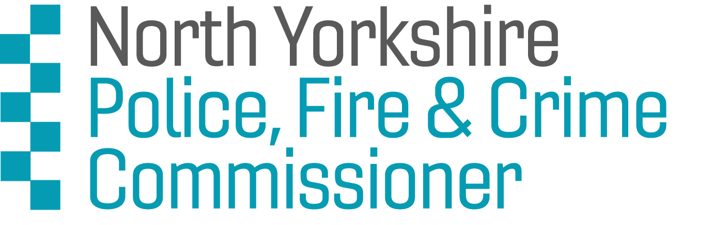

North Yorkshire Youth Commission on Police, Fire and Crime:
Application Deadline: Friday 25th Febuary 2022
Application Form
We are looking for applications from young people aged 10-25 across North Yorkshire* who would like to get involved in the North Yorkshire Youth Commission (NYYC). The Youth Commission enables young people to get involved and have their say about policing, fire and crime issues important to them.
*York, Harrogate, Selby, Skipton, Scarborough, Ryedale, Richmondshire and Hambleton

Section 1: Your details
NAME:

DATE OF BIRTH:
AGE:
HOME ADDRESS:

POSTCODE:
EMAIL:
LANDLINE:
MOBILE:
CURRENT OCCUPATION (Student at school, college, university, in work, unemployed):

NAMED PROFESSIONAL AND ORGANISATION THAT WOULD SUPPORT YOUR APPLICATION
(This could be a teacher, youth worker, tutor, lecturer, manager):

NAME OF YOUR SCHOOL/ COLLEGE/ UNIVERSITY/ YOUTH ORGANISATION:

If you are under 18 years old, please ask your parent/guardian/carer to provide the following details too. We will require written permission from them before we can confirm your place.
NAME OF PARENT / GUARDIAN / CARER:
HOME ADDRESS:

POSTCODE:
EMAIL:
LANDLINE:
MOBILE:

Section 2: More about you

- Why do you want to join the North Yorkshire Youth Commission on Police, Fire and Crime?
For example you might have specific skills, knowledge or life experiences that you’d like us to know about.

- Why do you think you should be selected for the North Yorkshire Youth Commission on Police, Fire and Crime?
For example, you might have specific skills, knowledge or life experiences that you’d like us to know about.

- Please tell us about yourself. Use up to 50 words to sum up your personality, interests or strengths. (Please stay within the word limit)

Section 3: Your availability

Please Note: We are carefully monitoring the ongoing Covid-19 pandemic. This means Members’ Meetings may be held virtually. We will give you more details closer to the time.

We will be holding the first session to look at NYYC priorities on Saturday 5th March 2022

Are you available to attend? Yes [ ] No [ ]

We will be holding the second session on Saturday 9th April 2022

Are you available to attend?

Yes [ ] No [ ]

Section 4: Diversity monitoring information
Leaders Unlocked and The North Yorkshire Police, Fire and Crime Commissioner are committed to promoting equality and diversity. We ask you to complete this form so that we can monitor and analyse information about the diversity of the people who submit an application. Any information you provide will be treated as strictly confidential. It will not be used by anyone directly involved in the selection process. We will transfer all the information provided into a database and then destroy all individual forms. No information will be published or used in any way that allows any individual to be identified. You are not obliged to answer the questions on this form. If you do not wish to answer a question simply answer ‘Prefer not to say’.

1. Your Gender (please put an X in the appropriate box)
Male Female Nonbinary Other Prefer not to say

1.a Do you identify as:

Cisgender Transgender Nonbinary Other Prefer not to say

1.b What is your preferred pronoun?

He/Him She/Her They/Them Xe/Xim Other Prefer not to say

2. Your sexual orientation (please put an X in the appropriate box)
Bisexual Gay man Gay woman/lesbian
Heterosexual Other Prefer not to say

3. Your religion or belief (please put an X in the appropriate box)
None Buddhist Christian
Hindu Jewish Muslim
Sikh Any other Prefer not to say

4. Your ethnic origin (please put an X in the appropriate box)

White
British English Welsh Scottish
Northern Irish Irish Gypsy or Irish Traveller European Other

Mixed/multiple ethnic background
White and Black Caribbean White and Black African
White and Asian Any other/ multiple ethnic background

Asian/Asian British
Bangladeshi Chinese Indian
Pakistani Any other Asian background

Black/African/Caribbean/Black British
African Caribbean
Any other Black/African/ Caribbean background

Other ethnic group
Arab Any other ethnic group Prefer not to say

5. Do you consider that you have a disability?

Yes No Prefer not to say

Section 5: When will I hear back?
We will conduct interviews with shortlisted candidates on the phone. All successful applicants will be informed by Wednesday 2nd March 2022
Please email your application forms back to emily@leaders-unlocked.org by Friday 25th February 2022

Section 6: How will Leaders Unlocked protect my privacy?
Your privacy is really important to us. By filling in the North Yorkshire Youth Commission application form, you are consenting to Leaders Unlocked using your personal information to keep in touch with you over the course of the project. If your application is not successful, or you decide to withdraw your application, we will delete your personal data from our files.

If you want to withdraw your consent at any time you can contact the Data Protection officer at info@leaders-unlocked.org and if you would like to see our full Privacy Notice you can do so here : Leaders-Unlocked-Privacy-Notice

We look forward to receiving your application!

