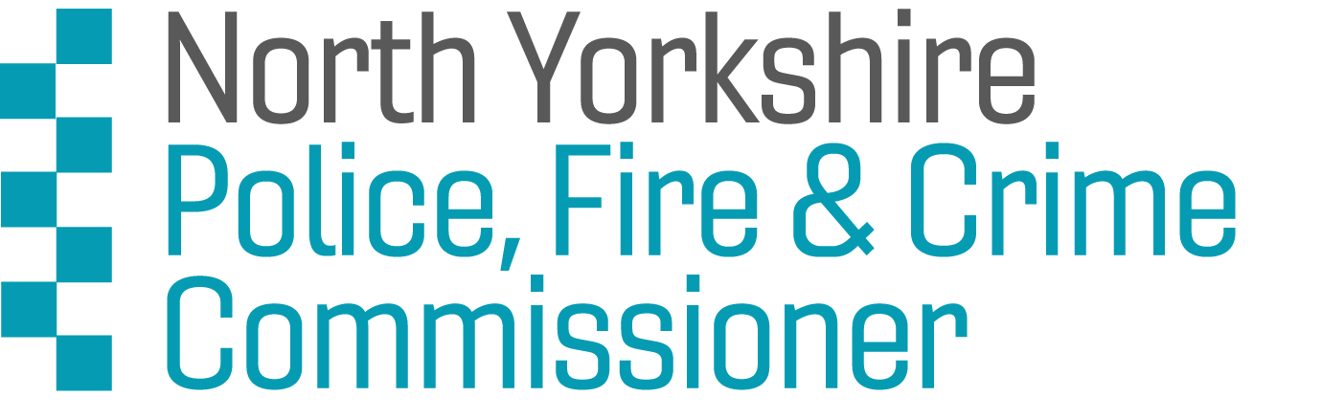

North Yorkshire Youth Commission on Police, Fire and Crime 2023

CONSENT FORM
If you are under 18, please ask a parent/guardian/carer to complete and sign this form.

I consent to [NAME OF YOUNG PERSON] becoming a member of North Yorkshire Youth Commission on Police, Fire and Crime.

Your name or Parent/guardian name [PRINT] :

Your name or Parent/guardian [SIGNATURE] :

Relationship to applicant :
Date :
Contact telephone number :
E-mail :

This form can be filled in digitally or scanned and emailed to emily@leaders-unlocked.org
Privacy: Your privacy is really important to us. By filling in the North Yorkshire Youth Commission application form, you are consenting to Leaders Unlocked using your personal information to keep in touch with you over the course of the project. If your application is not successful, or you decide to withdraw your application, we will delete your personal data from our files.
Communications : The named account holder / bill payer for any personal device(s) hardware and telecommunications network provider contract (Including Parents/guardians of NYYC members aged under 18) must sign to provide written consent to use their personal devices & network allowances for Youth Commission communications.
Media : The named person gives their permission to use all written materials, video footage, recordings and photographs taken for and by Leaders Unlocked for The Office of the Police, Fire and Crime Commissioner.
This includes: all footage, sound recording, still images or photographs taken of them, any quotes written or spoken taken from activities they attend. They understand that material may be used at different times and that they will not be contacted each time. They are aware that any footage, photographs or stories shared via social media could be shared further through external websites and digital platforms including national and international broadcasting and media outlets both print and online.
Some of the ways footage or photographs might be used include: on the Leaders Unlocked & the Police, Fire & Crime Commissioner’s website, on social media (Facebook, Twitter and Instagram for example, video-hosting platforms (YouTube and Vimeo for example), in publications (leaflets, posters, training materials or presentations), for broadcast (tv, radio, podcast) and any other appropriate use in line with the project.
If you want to withdraw your consent at any time you can contact the Data Protection officer at info@leaders-unlocked.org and if you would like to see our full Privacy Notice you can do so here : Leaders-Unlocked-Privacy-Notice

