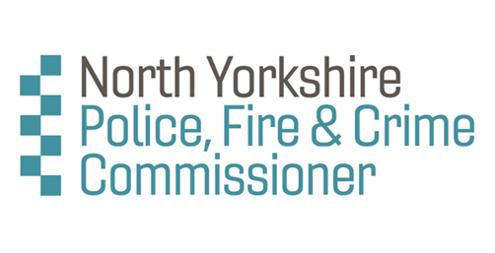

North Yorkshire Domestic Abuse and Rape Scrutiny Panel Application Form

Name
Contact Address
Contact Phone No
Email

- Please list any relevant groups/organisations you are currently involved with, whether in a paid or unpaid capacity, and include the geographical area covered by each group.
[Note: membership of groups or organisations is not necessarily a condition for joining the Panel]

- Please outline your experience of working in the field of domestic abuse and/or rape. Please include any experience of working directly with victims.
[your answer should be no longer than roughly one side of A4]

3. Please briefly outline your experience (if any) of working with the police, criminal justice system or other service providers [your answer should be no longer than roughly half a side of A4]
[Note: such experience is not necessarily a condition for joining the Panel]

4. Is there anything else you would like to tell us? [your answer should be no longer than roughly half a side of A4]
Please confirm that you are  willing to undergo the required Police Vetting Check | Yes / No

I declare that the information I have given is, to the best of my knowledge and belief, true and complete.

Signature:

Date:

Please return this form by no later than 21 March 2020 to Thomas.Thorp@northyorkshire-pfcc.gov.uk or Thomas Thorp at:

12 Granby Road
Harrogate
North Yorkshire
HG1 4ST

