LOCAL PENSION BOARD
Report of the Pensions Administrator / Manager
24 February 2021
PENSIONS UPDATE
- Purpose of Report
1.1 To provide Members with information on scheme membership and scheme changes as well as training, governance and communication issues.

2.0 Introduction

2.1 This report provides Members with scheme information, together with updates on current issues and training.

3.0 Scheme Membership Information

3.1 The following active memberships of the firefighters’ pension schemes are taken from pay data as at 15 January 2021 (for both Wholetime and On-Call Firefighters), and compared with active membership as at 23 October 2020 (for Wholetime Firefighters) and 15 October 2020 (for On-Call Firefighters).
3.1.1
Firefighters’ Pension Schemes Membership | Wholetime
 | 15/01/2021 | 23/10/2020
1992 | 28 | 32
2006 | 2 | 2
2015 | 254 | 254
Retained Modified | 2 | 3
Opted Out | 14 (4.65%) | 10 (3.62%)

3.1.2 The variations for wholetime membership are as follows:
- 1992 scheme 2 retirements
2 transitions into the 2015 scheme

- 2006 scheme no movement
- 2015 scheme 7 starters (WT recruitment, on-call staff on temporary WT or
OSR posts)
5 leavers
2 transitions from the 1992 scheme
4 Opt outs
- Retained modified 1 retirement
scheme

- Opt Outs 4 members have opted out of the 2015 Scheme since the
16 December 2020 Board meeting.

3.2
Firefighters’ Pension Schemes Membership | On-Call
 | 15/01/2021 | 15/10/2020
1992 | 0 | 0
2006 | 4 | 5
2015 | 309 | 300
Retained Modified | 9 | 10
Opted Out | 14 (3.79%) | 12 (3.40%)

    - The variations for On-Call membership are as follows:
- 2006 scheme 1 transition into the 2015 scheme
- 2015 scheme 22 starters (new employees)
1 transition from standard 2006 scheme
9 leavers
3 retirements
2 Opt outs

- Retained modified 1 retirement
Scheme

- Opt Outs 2 members have opted out of the 2015 Scheme since the 16
December 2020 Board meeting.

3.3 The following table shows the retired members according to each scheme as at 15 February 2021 compared to 12 November 2020. Membership continues to be split between pensioners and dependants.
3.3.1
Firefighters’ Pensions Schemes Retired Membership | 15/02/2021 | 12/11/2020
1992 (Pensioners) | 444 | 443
1992 (Dependants – widow / partner / child pension) | 81 | 83
2006 | 19 | 19
2006 (Dependants – widow / partner / child pension) | 1 | 1
2015 | 13 | 10
2015 (Dependants – widow / partner / child pension) | 3 | 3
Retained Modified | 53 | 52
Retained Modified (Dependants – widow / partner / child pension) | 2 | 2

3.3.2 The variations for members with a pensioner status are as follows:
- 1992 scheme 2 retirement from active status implemented
1 death of pensioners
1 death of dependant

- 2006 scheme no movement
- 2015 scheme 3 retirement from active status implemented

- Retained modified no movement
scheme

3.4 The following table shows the deferred members of each scheme as at 15 February 2021, compared to those as at 12 November 2020.
3.4.1
Firefighters’ Pensions Schemes Deferred Membership | 12/11/2020 | 12/11/2020
1992 | 28 | 28
2006 | 147 | 147
RDS Modified | 27 | 27
2015 | 198 | 194

3.4.2 The variations in deferred pension members cover pensions that have come into payment, leavers and those who have opted out of the scheme (who don’t qualify for a refund of their contributions).

4.0 Internal Dispute Resolution Procedure (IDRP)

4.1 There is an Internal Dispute Resolution Procedure for dealing with any complaints. Initial information on this two-stage process can be found at:
http://www.wypf.org.uk/Member/Fire/IDRP/InternalDisputeResolutionPro.aspx
There have been no new IDRP applications since previous meeting.

5.0 Pension Board Training Update

5.1 Overview of each of the Firefighters’ Pension Schemes (to be delivered by WYPF) – at this 3 March 2021 Board meeting.

- Other Work Items

  - Monthly postings up to and including January 2021 have been submitted to West Yorkshire Pension Fund (WYPF).

  - Following confirmation of 2020s national pay award (and local CPD increase), the post-1 July 2020 retirements that were processed using 2019s pay rates, were recalculated with the revised 2020 pay rate plus CPD contribution amounts and/or pensionable public holiday payments (where applicable) submitted to WYPFs prior to their 31 January deadline.

  - The annual Pensions Regulator’s Public Service Governance & Administration Survey that is sent to all public sector schemes was received during January (somewhat later than in previous years). This was completed by the Pensions Administrator / Manager and submitted by their 12 February deadline. The completed survey is attached.

  - The data collection spreadsheet, and guidance, in relation to the annual Government Actuary’s Department (GAD) exercise for the 2020/21 IAS19 Valuation for the statutory accounts was received 12 February. This requires input from WYPF, the Pensions Administrator / Manager and the Head of Finance to report, by GADs deadline of 12 March, scheme membership numbers and pensionable pay figures, with all findings that fall outside of GADs expected tolerances investigated and explained.

  - HMT provided their response to the remedy consultation on 4 February. The Pensions Administrator / Manager emailed scheme members on 11 February to advise them that the ‘Deferred Choice Underpin’ (DCU) was the government’s preferred method of tackling remedy – as expected – as this would allow member’s to make their choice of which scheme they want to be regarded as being a member of at the point of retiring / leaving, as this minimises the risk of an inappropriate choice being made (as their career path / personal circumstances would have already happened). The email attempted to re-emphasise that the full extent of the detail wouldn’t be known until regulations were drafted, consulted upon, and laid.

  - Scheme Advisory Board (SAB) levy for 2020/21 was paid by the due date.

- Discretions made by Scheme Manager

7.1 The Scheme Manager is responsible for the operation of the scheme, and the Police, Fire and Crime Commissioner is regarded as the Scheme Manager. However, this duty has been delegated to the Pensions Administrator / Manager.

7.2 For the period 1 October to 31 December 2020, no discretions needed to be exercised.

7.3 However, the Scheme Manager has exercised two discretions so far for the current quarter.

7.4 both relate to wholetime members of the 2015 scheme that enquired about transferring previous pension benefits from non-occupational schemes a matter of weeks past their 12-month anniversary of joining.

7.5 Regulation 141(3) of the 2015 scheme’s regulations (the Firefighters’ Pension Scheme (England) Regulations 2014) state that transfers should be requested for a non-occupational pension scheme within the first 12 months of the individual becoming an active member:

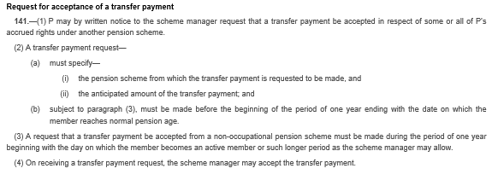

7.6 As the discretions are close to completion, and this discretion is being amended to allow transfers beyond the first 12 months, the Pensions Administrator / Manager advised WYPF that both cases could proceed.

- Legislative update

SI | Reference title
2020/1332 | The Occupational Pensions (Revaluation) Order 2020

- Firefighters’ Pension Schemes Bulletins Summary

Joint statement on age discrimination remedy
Please see below a joint statement issued on 4 December 2020 by the Home Office and LGA Bluelight team regarding public service pensions age discrimination remedy:

“As you are aware the Treasury’s public consultation on the Public Sector Pension remedy closed on the 11 October. This note is intended to outline next steps for delivery of the remedy.

The Treasury are currently considering consultation responses and expect to publish their response to the consultation in the new year. This will outline the policy intent of the remedy, including whether immediate or deferred choice will be adopted.

Changes to both primary and secondary legislation will be required to remove the discrimination. The Home Office will need to work with the Treasury to understand the policy and proposed legislation and to draft regulations to make the changes required for the Fire schemes.

In order to deliver the remedy to the timeline set out by the Treasury, the Home Office and the LGA Bluelight pensions team are committed to ensuring that you are fully up to speed with all policy and regulation developments so that work can progress at pace. It will be essential that Fire and Rescue Authorities start the process of considering what technology/administration processes will be required to implement the remedy, including what data should be retained, at the earliest opportunity and we will be engaging with you further to understand your dependencies and any challenges you will face.”

Firefighters’ Compensation Scheme
In FPS Bulletin 39 - November 2020 we commented on identifying a qualifying injury. We have received further requests regarding the FRA’s position on the compensation scheme, and we offer the following points that may assist when making determinations under the compensation scheme:

- The compensation scheme is the responsibility of the employing FRA, payments from the scheme are paid from the Fire and Rescue operating account, not the notional pension account topped up by Government as per paragraphs 3.23 to 3.29 of the finance guidance.
- There have only been minor amendments to the compensation scheme rules since 2006.
- The entitlement to an injury award under the compensation scheme occurs if the infirmity is occasioned by a ‘qualifying injury’ [Part 2, Rule 1, sub para 1]
- ‘Qualifying Injury’ in defined in Part 1,Rule 7. There has only been a minor amendment to this rule by SI 2014/447 which substituted ‘regular firefighter’ for ‘regular or retained firefighter’ “references in this Scheme to a qualifying injury are references to an injury received by a person, without his own default, in the exercise of his duties as a regular or retained firefighter.”
- Regular firefighter is defined in the interpretations as “regular firefighter” means—
(a) a person who is employed—
(i) by a fire and rescue authority as a firefighter (whether whole-time or part- time), other than as a retained or volunteer firefighter; and
(ii) on terms under which he is, or may be, required to engage in firefighting or, without a break in continuity of such employment, may be required to perform other duties appropriate to his role as a firefighter (whether instead of, or in addition to, engaging in fire-fighting) and whose employment is not temporary;
(b) a person who holds office as the London Fire Commissioner where the terms and conditions of appointment to that office include—
(i) resolving operational incidents, or
(ii) leading and supporting others in the resolution of operational incidents;”
- Retained firefighter is defined by the interpretations as “retained firefighter” and “retained or volunteer firefighter” mean a person employed by an authority—
(a) as a firefighter, but not as a regular firefighter,
(b) on terms under which he is, or may be, required to engage in fire-fighting or, without a break in continuity of such employment, may be required to perform other duties appropriate to his role as a firefighter (whether instead of, or in addition to, engaging in fire-fighting),
(c) otherwise than in a temporary capacity, and
(d) who is obliged to attend at such times as the officer in charge considers necessary, and in accordance with the orders that he receives;”
- It is for the FRA to consider whether the qualifying injury occurred ‘in the ‘exercise of duties’ as a ‘regular or retained firefighter'.
- It would not be appropriate for anyone other than the employer to determine what is the exercise of duties as a firefighter; the regulatory definitions of a regular or retained firefighter do not refer to the role map, rather to their employment as a regular or retained firefighter.
- FRAs should take into account what the contractual arrangements for additional duties are and whether these are in the context of the existing contract as a firefighter, or whether these are contracted for separately with no reference to being employed as a firefighter. You may be aware of the employers circular FAQs Q12 regarding volunteering for additional duties “What is the position in respect of my pension” to which the answer is:
“You are volunteering to assist your service's response to the pandemic, thereby agreeing to undertake a variation to your normal duties following a reasonable request by your employer. You are therefore undertaking authorised duty within the context of your existing contract and the pension scheme rules.”

IQMP assessments
At their meeting on 10 December 2020, the Scheme Advisory Board (SAB) discussed a paper updating Board members on medical retirements from the FPS.

The Board agreed that the paper should form a factsheet update to stakeholders on ill-health and injury retirements and that it would proceed with forming a review group for guidance. In consideration of the question on the ability of an Independent Qualified Medical Practitioner (IQMP) to make an assessment under both the legacy and reformed schemes [paragraphs 30 to 33], the Board agreed for the secretariat to draft a statement on behalf of SAB to confirm that IQMPs may assess the same member against the criteria of multiple schemes for recognised purposes including injury awards under the compensation schemes, transitional deferred benefits, and age discrimination remedy/ immediate detriment.

This statement is included below:

“In cases of immediate detriment, some IQMPs have felt unable to make assessments under two schemes, due to wording in the scheme regulations that state the IQMP should not previously have been involved in a case for which his/her opinion has been requested, and they feel that whether the IQMP can express an opinion on both schemes simultaneously is unclear.

While the Board recognise that neither they, the LGA or the Home Office can provide a definitive interpretation of the regulations as only a court can provide a definitive interpretation of legislation, they are satisfied that the regulation wording should not prevent IQMPs from giving an opinion on both schemes, citing the example that this is currently the position for injury and ill-health retirements or deferred pension illhealth retirements, where the IQMP assesses the member under both the compensation scheme and pension scheme, or from both pension schemes for a deferred members retirement. In consideration of the question on the ability of the IQMP to make an assessment under both the legacy and reformed schemes, the Board confirm that IQMPs may assess the same member against the criteria of multiple schemes for recognised purposes including injury awards under the compensation schemes, transitional deferred benefits, and age discrimination remedy.”

TPR six key processes factsheet 2021
We advised readers in FPS Bulletin 39 – November 2020 that the results of the 2019 Governance and Administration survey had been published by the Pensions Regulator (TPR).

As part of the annual survey, TPR measures six processes as key indicators of public service pension scheme performance. The six processes are:

1. Documented policy to manage board members conflicts of interest
2. Access to knowledge, understanding and skills needed to properly run the scheme
3. Documented procedures for assessing and managing risks
4. Process to monitor records for accuracy / completeness
5. Process for resolving contribution payment issues
6. Procedures to identify, assess and report breaches of the law

In 2019, 55 per cent of Firefighters’ schemes across the UK reported having all six processes in place. This had reduced from 63 per cent in 2018.

Figure 1: Spider graph showing schemes' performance against the six key indicators

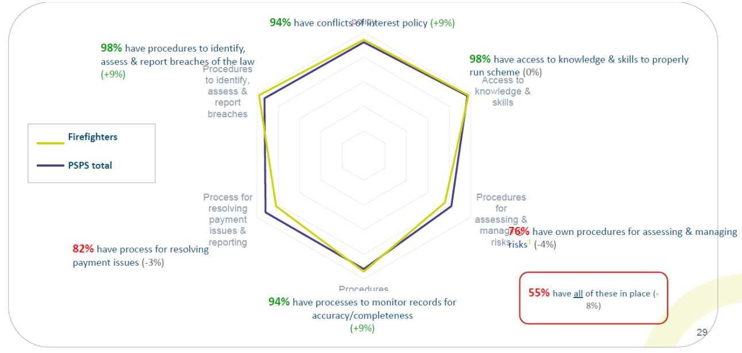
Source: Local Pension Board Wrap Up Training 2020 [slide 29]

We have refreshed our six key processes factsheet to reflect the most recent results and give guidance to FRAs and their Local Pension Boards (LPBs) to improve understanding and compliance in the next survey.

Other News and Updates Public Service Pension Indexation and Revaluation 2021
On 12 January 2021, HMT issued written statement HLWS699 confirming the Public Service Pension Indexation and Revaluation for 2021.

Public service pensions will be increased in line with the annual increase in the Consumer Prices Index up to September 2020. The increase from 12 April 2021 is 0.5%.

HMT has published the 2021 pensions increase multiplier tables and covering note to the GOV.UK website in advance of the Pensions Increase (Review) Order being laid.

FPS 2015 will use the figure of 2.4% as set out in the statement for the earnings element of revaluation for active members to be applied at one second after midnight on 31 March 2021.

Pensions Dashboards Programme – welcome to 2021
The Pensions Dashboards Programme (PDP) published a blog on 12 January 2021 entitled ‘welcome to 2021 and brighter days ahead’. The blog outlines progress made by the PDP in 2020 and sets out milestones for the year ahead.

A significant step for the PDP will be the Pensions Schemes Bill 2019-21 passing into law. The Bill will set out high-level legislative requirements that schemes and providers must comply with. In addition, the PDP expects to start a program of procurement for the digital infrastructure needed to support dashboards.

FCA publishes DB transfer advice tool The Pension Schemes Act 2015 (Transitional Provisions and Appropriate Independent Advice) Regulations 2015 introduced the requirement for members to take independent advice where the value of their transfer value exceeds £30,000. On 15 January 2021, the Financial Conduct Authority (FCA) published the Defined Benefit Advice Assessment Tool.

The purpose of the tool is to allow the industry to understand how the FCA assesses advice suitability given before October 2020. The FCA will publish an updated tool reflecting changes made to pension transfer permissions in October 2020 during the coming months.

Government updates Brexit pension guidance The Government has updated the Brexit pension guidance to reflect that the State Pension will continue to be increased while the person is resident in the EU and that the transition period has ended.

10.0 West Yorkshire Pension Fund Key Performance Indicators

10.1 WYPF provides monthly reporting on administration matters and Key Performance Indicators (KPI). The latest KPI results are shown below.
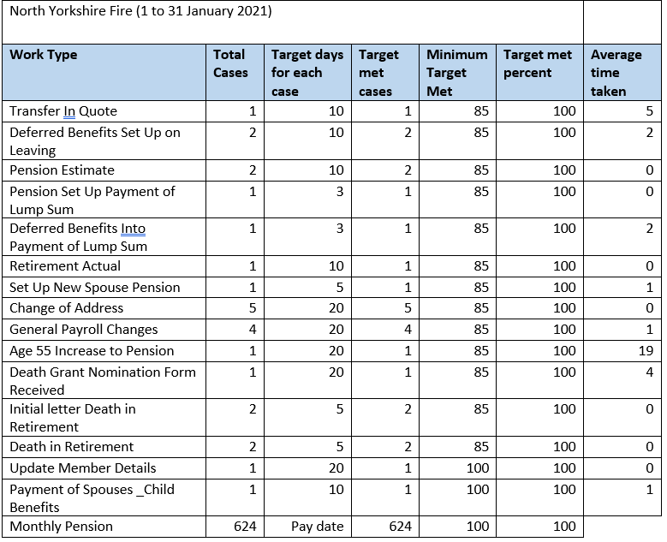

11.0 Recommendations
11.1 That Members note the content of the report.

David Hood
Pensions Administrator / Manager
24 February 2021

Background documents:
2015 Firefighters’ Scheme Complaints and Dispute process:
http://www.wypf.org.uk/Member/Fire/IDRP/InternalDisputeResolutionPro.aspx
the Pensions Regulator’s annual survey on Administration and Governance

