|  |  |
| --- | --- |
|  |  |

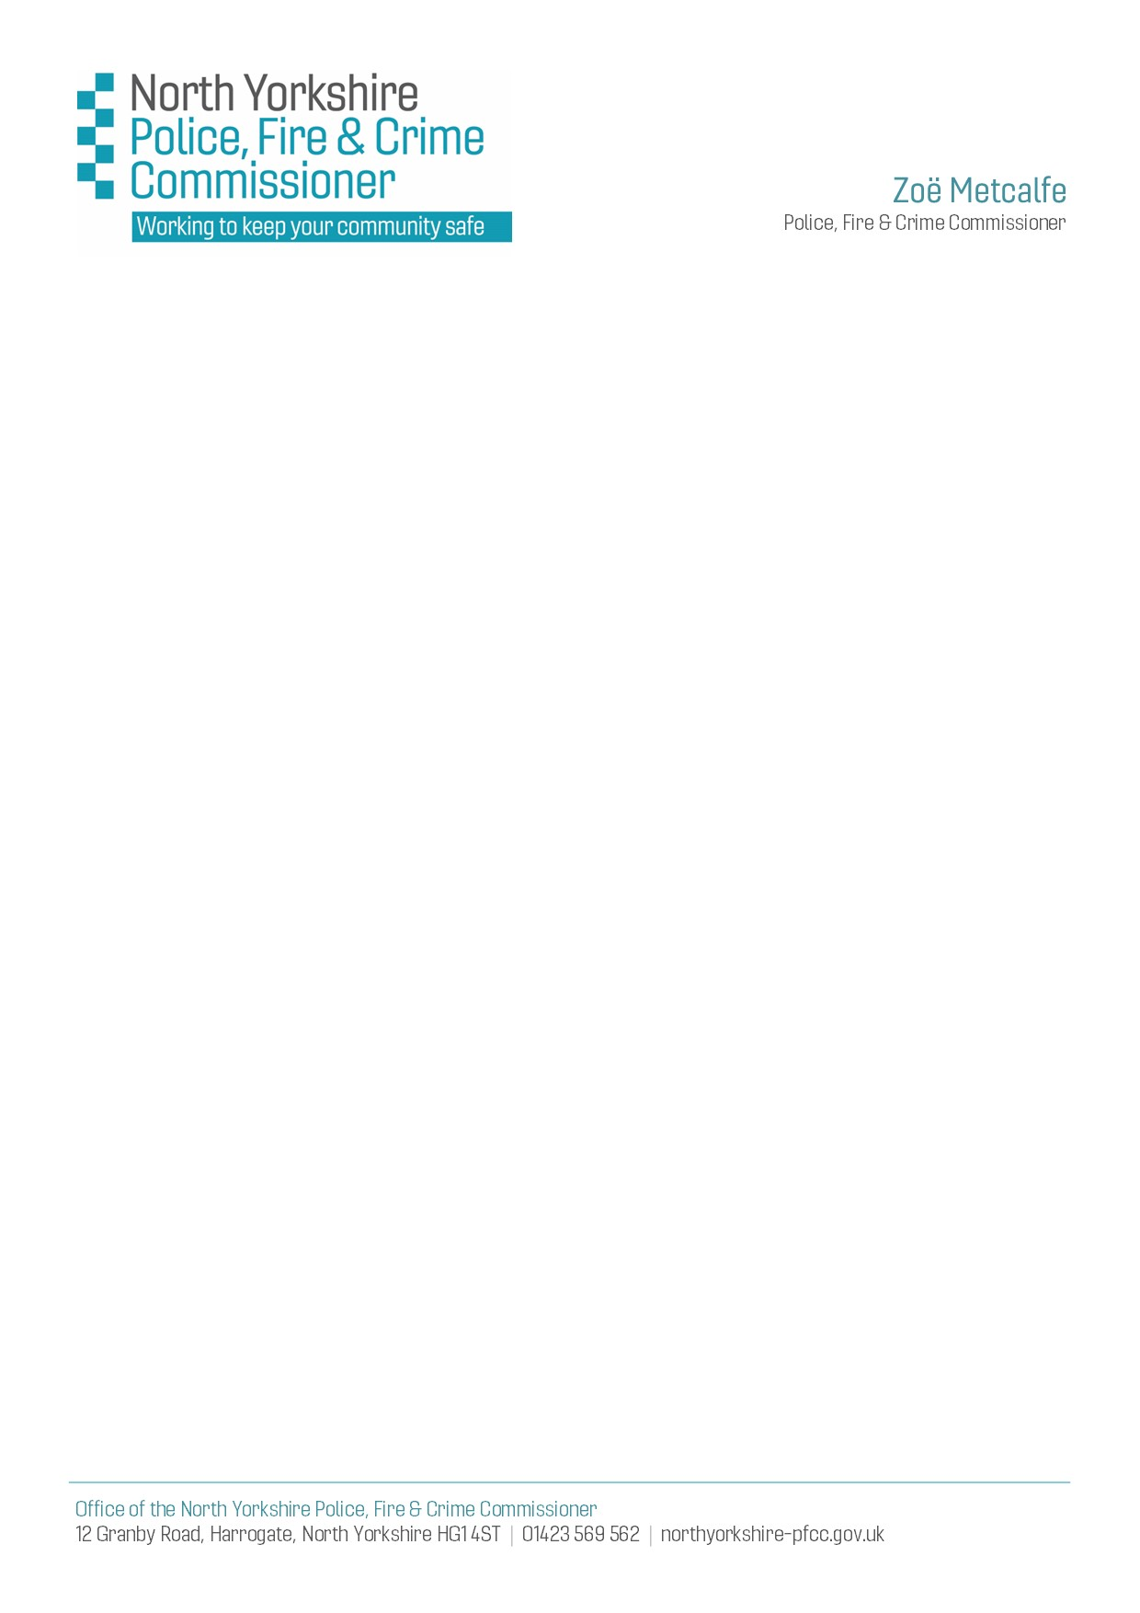

**21st April 2022**

**Summary of Q&As in respect of Domestic Abuse & Sexual Violence Support Services Funding Opportunity**

## **Funding Allocation Process**

1. **Will funding allocations for the coming year be dependent upon NYPFCC being successful in securing some of this additional MOJ funding and in turn local organisations being successful in bidding into any funding that is secured by NYPFCC?**
   1. No - NYPFCC cannot apply for this MoJ funding and we do not have an allocated or indicative amount of funding available for services in North Yorkshire.

NYPFCC are required to promote this opportunity and then coordinate, collate and review all funding requests submitted locally to confirm they meet the funding eligibility criteria as set by the MoJ.

NYPFCC are also required to provide a Local Needs Assessment and indication of whether we support individual funding requests to assist the MoJ who will then make the final decision of all allocations of funding nationally.

## **Eligible Costs & Roles**

1. **Can bidders include a proportion towards service overheads within funding requests?**
   1. ID/SVA Funding can only be used to employ specific posts / FTEs and associated costs, including training and on-costs but not overheads.

However, the Community-based D&SA Support Services Funding is available to support direct service delivery and therefore can be used for ‘wrap around’ and other associated costs to facilitate delivery of support such as a proportionate contribution towards overheads including administrative and management support, office, utilities, etc.

1. **Would a Trauma Therapist be eligible within the scope of the ID/SVA Funding criteria?**
   1. No – the only roles eligible for ID/SVA Funding are ID/SVAs and caseload carrying ID/SVA Managers who meet the definitions as set out in the [SafeLives National Definition of IDVA Work](https://safelives.org.uk/sites/default/files/resources/National%20definition%20of%20IDVA%20work%20FINAL.pdf) and the [Home Office ‘Essential Elements of the ISVA Role’](https://assets.publishing.service.gov.uk/government/uploads/system/uploads/attachment_data/file/647112/The_Role_of_the_Independent_Sexual_Violence_Adviser_-_Essential_Elements_September_2017_Final.pdf)

Whilst there are a variety of different job titles to describe workers carrying out ID/SVA roles, the essential elements set out in these documents will apply to any posts applied for under ID/SVA funding, specifically the requirements to:

* Complete specialist accredited training and hold a nationally recognised qualification
* Provide ongoing end-to-end emotional and practical support, advocacy and impartial advice and information, and facilitate access to other specialist support such as pre-trial therapy and counselling, and services to address other interdependencies in relation to health and social care, housing, or benefits.

Psychological therapy and counselling are outside the scope of ID/SVA roles, and ID/SVA roles are distinct from that of a crisis worker, counsellor and outreach support worker.

Such roles would be eligible however within the scope of the Community-based D&SA Support Services Funding.

## **Specialist Support & 'by & for' Services**

1. **Would NYPFCC consider supporting an application for a Police Force/PCC area cross border specialist 'by and for' such as a BAME worker where these currently do not exist?**
   1. We would support a proposal for a cross-border specialist role - one of the MoJ funding priorities is to better meet the needs of under-represented victims and therefore we are encouraging applications for ‘by and for’ support services – ideally we like to see how any such posts or services could be aligned to existing commissioned support services to ensure consistency and parity of support offered to all victims and survivors whilst meeting the specific needs of those with protected characteristics.
2. **Does the question** **on the Funding Request Form about protected characteristics merely mean that we work with BAME along with other groups but not exclusively?**
   1. The question asks – ‘Does the Service / Project / Role/s support one or more protected characteristic, and is this exclusively?’

Please answer 'YES / NO / Not Applicable' as indicated to confirm initially whether you support any victims with protected characteristics, and if 'YES' confirm if 'EXCLUSIVELY' or 'NOT' as indicated providing brief details to explain this response.

i.e. if you support all victims regardless of protected characteristics as part of your overall service offer but do NOT exclusively support only BAME victims then answer this question 'YES' then 'NOT EXCLUSIVELY' and state 'We support all victims regardless of protected characteristics' along with any other relevant details such as whether you have any specialist 'by and for' workers or those specially trained in supporting these victims to ensure their specific needs are met.

1. **Does the question on the Funding Request Form about male victims merely mean that we work with male victims along with female & other victims but not exclusively?**
   1. As Q5 above.

## **Providers of Support for both DA & SV**

1. **Do bidders need to provide a proportional split between DA & SV clients and complete both sections of the Funding Request Form for clients who have also experienced SV as part of an abusive relationship?**
   1. No – where clients have experienced sexual violence or abuse within an abusive intimate relationship, they should be included within DA Support Services sections only; the Sexual Violence Support Services sections only need to be completed in respect of clients who have experienced SV or sexual abuse outside of an abusive intimate relationship, including child sexual abuse or exploitation.
2. **Do bidders need to repeat what is said for the three questions asking about evidence where the split between DA and SV clients is 50:50?**
   1. We have to evidence need for the support services split by DA or SV, and the MoJ require all funding requests to be split accordingly based on the primary concern/support need with specific evidence of need provided for each cohort; see Q7 above for clarification of where to included clients how have experienced SV as part of an abusive intimate relationship.

Therefore, please ensure your responses are tailored specifically to evidence need for DA support and SV support separately if applicable; do not just repeat the same information twice for both cohorts.

i.e. if your caseloads are split approximately 50/50 then please refer to half your current caseloads/waiting lists as an indication of need if you are unable to provide specific figures for each cohort.

1. **Do bidders have to split costs between DA and SV or just enter the total figures in one column?**
   1. As Q8 above - the MoJ require the funding requests to be split by DA or SV so please split the associated costs accordingly; if you are unable to provide exact figures/costs per cohort but caseloads are split approximately 50/50 then please request funding with costs split 50/50.

## **Waiting Lists**

1. **Can bidders provide waiting list figures as at April, rather than February?**
   1. No - the MoJ require the actual number of people on the waiting list at the end of February 2022.