**York and North Yorkshire Good Citizen Award- Design Worksheet**

**Young Person’s Details**

|  |  |  |  |
| --- | --- | --- | --- |
| Name |  | Age |  |
| Organisation |  | Local Area |  |
| Contact Details  (If applicable) |  | | |

**Award Mentor’s Details**

|  |  |  |  |
| --- | --- | --- | --- |
| Name |  | Organisation |  |
| Email Address |  | Contact Number |  |
| Relationship to the Young Person |  | | |

1. **What positive action are you going to take and what key qualities of good citizenship do you expect to use?**
2. **How will your positive action benefit the community?**
3. **When will you carry out your positive action? (Expected start/ finish dates)**

**Young person’s signature:**

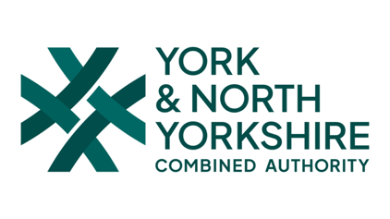**Award Mentor’s signature:**