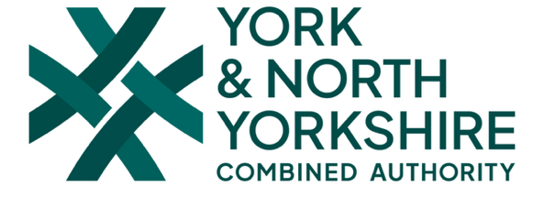


Women Unlocked Mentoring Programme:
APPLICATION DEADLINE: Friday 10th April 2026
What is the Women Unlocked Mentoring Programme?
The Women Unlocked Mentoring Programme is an individual and group mentoring project for young women and girls aged 16-24. By taking part you will work individually with an experienced mentor on personal development topics, such as, CV writing, interview skills, confidence and deciding what's next for you in life (Plus, lots more- It’s all about what YOU want to work on).
You’ll also be part of a group of other young women coming together to tackle gender inequality. This will include working with partner groups, like the York & North Yorkshire Combined Authority; North Yorkshire Police; North Yorkshire Fire and Rescue Service and more, to tell them how they can better protect and support an young women.
You will also work together to continue the Women Unlocked’s ‘Reporting Campaign’, including the opportunity to visit groups of other young people in your community to promote your campaign.

Mentor
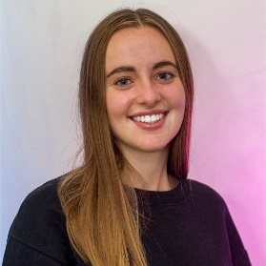
Meet Amber, she will be your mentor. Amber has several years of experience mentoring in lots of different situations, including young people and university students. She’s friendly and approachable and looking forward to working with you.

Who can get involved?
The Women Unlocked Mentoring Programme is open to anyone who:
- Identifies as female
- Is aged 16-24
- Lives, works or studies in York or North Yorkshire

How long is the mentoring Programme and how much time will it take up?
The programme will last for 6 months. During this time, you will complete three personal mentoring sessions (usually online unless you prefer otherwise) and three group development days. This will work out to one session per month.
There will also be opportunities to take part in more special events and sessions for those who are interested.
Personal Mentoring Sessions:
These will be online sessions between you and your mentor. You will get the opportunity to discuss your goals and how to achieve them. This could include things like confidence building; interview practice; how to look for jobs; CV and application writing and lots more.
Group Development Days:
Group development days will take place on Saturdays in-person and will give you the chance to work with other young women and professionals. These days will include team-building activities; planning and further designing your Reporting campaign and discussions with special guests.

What will I get from being involved?
Personal Development- You will get the opportunity to work closely with an experienced mentor on your own personal development. This will include figuring out what goals you want to achieve and being supported to reach them.
Tackling Gender Inequality- You will work with other young women and professionals to help to address different types of gender inequality and Violence Against Women & Girls.
References- Your mentor will be able to provide you with references for future opportunities including College/University/Apprenticeship applications and job/ volunteering opportunity applications.
Talent Unlocked- On completing the Women Unlocked Mentoring programme you will have the opportunity to join Talent Unlocked, a special network that will provide you with further project opportunities.

How do I take part?
To get involved, fill out an application form on google docs (link below).

You can find the application form here: https://docs.google.com/forms/d/e/1FAIpQLSeZOrXv-Rn6-TzGfIKF2Qbh77hLFDwh78BD3tOHicaf2EUFOw/viewform

If you would prefer to complete your application form over the phone- That’s fine too. Email Emily on Emily@leaders-unlocked.org to arrange this.

If you have further questions or want to chat about the opportunity more please contact Emily on Emily@leaders-unlocked.org or 07782564022

Thank you!

